Report No. 13.11 PLANNING - NSW Employment Zones Reform - Plannning Proposal: Additional permitted uses for Certain Lots within Zone E4 General Industrial, Centennial Circuit - Byron Arts and Industry Estate

**Directorate:** Sustainable Environment and Economy

**Report Author:** Kristie Hughes, Natural Disaster Policy Planner

**File No:** I2024/966

Summary:

This report seeks Council’s authorisation to prepare and submit a planning proposal to allow Additional Permitted Uses on certain lots within Zone E4 General Industrial, located on Centennial Circuit in the Byron Arts and Industry Estate.

In 2022 the Department of Planning, Housing, and Infrastructure (DPHI) implemented employment zone reforms. The updated framework replaced existing business and industrial zones with consolidated employment zones, utilising savings, and transitional provisions to assist with managing the change and allowing existing land use permissibility to remain in place until April 2025. A number of Councils are undertaking similar planning proposals to address missing land uses in the new zones during the savings provision period.

The planning proposal will allow five (5) additional land uses that were previously permitted on land permitted zoned B7 Business Park, but not included in the E4 General Industrial zone that currently applies to the land. This change will better align with the existing land uses in this precinct and responds to submissions received in response to DPHI’s public exhibition of the ‘Employment Zones.

Pending positive Gateway determination, the planning proposal will be exhibited in accordance with the determination requirements. A Submissions report post-exhibition will be presented to Council that includes any recommended changes to the planning proposal for final adoption.

NOTE TO COUNCILLORS:

In accordance with the provisions of S375A of the Local Government Act 1993, a Division is to be called whenever a motion for a planning decision is put to the meeting, for the purpose of recording voting on planning matters. Pursuant to clause 2(a) under the heading Matters to be Included in Minutes of Council Meetings of Council's adopted Code of Meeting Practice (as amended) a Division will be deemed to have been called by the mover and seconder of all motions relating to this report.

RECOMMENDATION:

**That Council:**

**1. Authorises staff to prepare and submit a Planning Proposal to allow additional permitted land uses on certain lots within Zone E4 General Industrial, located on Centennial Circuit of the Byron Arts and Industry Estate and as shown in Figure 1 of this report.**

**2. Pending a positive Gateway determination, exhibits the Planning Proposal in accordance with the determination requirements.**

**3. Receives a Submissions report post-exhibition that includes any recommended changes to the Planning Proposal for final adoption.**

**Attach the Special Disclosure of Pecuniary Interest Annexure for matters relating to environmental planning instruments #E2012/2815.**

**Attachments:**

1 Form of Special Disclosure of Pecuniary Interest, E2012/2815

## Background and Report

In 2022, the NSW Department of Planning, Housing and Infrastructure (DPHI) introduced [employment zones reform](https://www.planning.nsw.gov.au/policy-and-legislation/planning-reforms/employment-zones-reform) to all local government areas in NSW. The new employment zones replaced the business and industrial zones in the Byron LEP 2014.

In late 2021, Councils across NSW were asked to provide feedback on specific zone and land use reforms that would apply to their respective local government areas. Council staff reviewed the proposed changes and provided feedback to the department in early 2022, holding a Strategic Planning Workshop with Councillors to discuss the new framework which was [adopted](https://byron.infocouncil.biz/Open/2022/04/OC_28042022_MIN_1474.htm#PDF2_ReportName_9717) (**Res. 22-169**) at the Council meeting of [28 April 2022.](https://byron.infocouncil.biz/Open/2022/04/OC_28042022_AGN_1474.htm" \l "PDF2_ReportName_9717)

The new employment zones came into effect in April 2023, including savings and transitional provisions to maintain existing land use permissibility until April 2025, providing Councils with a two-year period to finalise the required amendments to their LEPs.

Reason for the reforms

The rationale for the DPHI employment zones reform is to support long-term economic recovery through job creation and to encourage increased productivity in NSW. The simplified employment zones framework is designed to be more compatible with the future of work, while facilitating the delivery of strategic plans and planning priorities. In general, the reforms provide for greater land use flexibility, particularly in industrial zones.

A principle underpinning the employment zones reform is that land uses permitted under the previous zoning should continue to be permitted for a two-year “transition period” following the introduction of the new employment zones.

Changes to Byron LEP 2014

The reforms introduced the following changes to planning controls in Byron LEP 2014:

* The repeal of 6 previous business zones, replaced by 4 consolidated employment zones.
* Updated zoning maps to reflect the new land use zones.
* New land use tables to govern the objectives and permitted/prohibited uses for each new zone.

Councils were tasked with reviewing the proposed translation of zone objectives and land use controls from the previous zones into the proposed zones, to minimise the loss of land use permissibility. Meaning land uses in each location that were previously permitted with consent should generally remain as ‘permitted with consent’ wherever possible to maintain consistency.

Following the above changes to Byron LEP 2014 and noting the savings and transitional provisions will expire in April 2025, staff undertook a review of land use permissibility on lots that were previously zoned B7 Business Park, and are now E4 General Industrial, in the Byron Arts and Industry Estate.

This review relates to the area of E4 General Industrial Zone (previously B7 Business Park) shown with a yellow border in Figure 1.

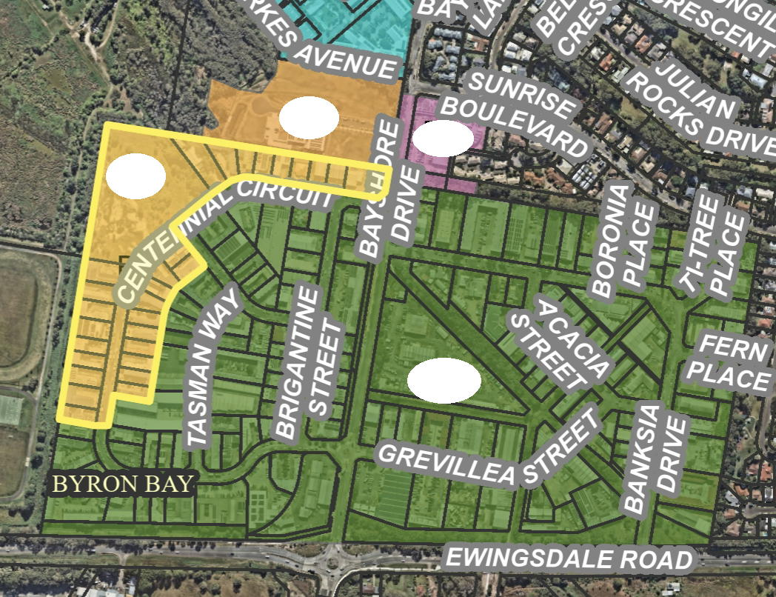

E1

E3

E4

E4

Figure 1: Employment Zones in the Byron Arts and Industry Estate.

**Planning Proposal to include additional permitted uses on certain lots within the Byron Arts and Industry Estate**

Parts of the Industrial Estate that were previously zoned [B7 Business Park](https://legislation.nsw.gov.au/view/html/inforce/2021-02-26/epi-2014-0297#pt-cg1.Zone_B7) have been replaced with [Zone E4 General Industrial](https://legislation.nsw.gov.au/view/html/inforce/current/epi-2014-0297#pt-cg1.Zone_E4) (as shown in Fig 1 above), due to the existing uses in the precinct being most suited to this zone. However, there are existing land uses, that are not permitted in the E4 Zone but continue to operate within the previous permissions under the B7 Zone. To address this, an LEP amendment to introduce additional permitted land uses on lots that were previously in the B7 Business Park, but have since transitioned to the E4 General Industrial, is proposed to better align with the existing land uses in this precinct.

It is considered that ‘Hazardous Industries’ and ‘Offensive Industries’ remain prohibited (as part of the ‘Industries’ group) in within land use table due to potential land use conflicts.

Specifically, the planning proposal will update [Schedule 1 Additional permitted uses](https://legislation.nsw.gov.au/view/html/inforce/current/epi-2014-0297#sch.1) and the corresponding [Additional Permitted Uses Map](https://eplanningdlprod.blob.core.windows.net/pdfmaps/1350_COM_APU_003CC_020_20221111.pdf) in LEP 2014 to include the proposed uses highlighted **red** in the table below

The lots bordered in yellow in Figure 1 will be added to the Additional Permitted Uses Map.

Table 1. Current and Proposed Additional Permitted Land Uses Zone E4 General Industrial.

|  |  |
| --- | --- |
| **Current:**  [Zone E4 General Industrial](https://legislation.nsw.gov.au/view/html/inforce/current/epi-2014-0297#pt-cg1.Zone_E4) | **Proposed:**  Zone E4 General Industrial  (Additional permitted uses highlighted in **red)** |
| **2. Permitted without consent**  Environmental protection works | **2. Permitted without consent**  Environmental protection works |
| **3. Permitted with consent**  Depots; Freight transport facilities; Garden centres; General industries; Goods repair and reuse premises; Hardware and building supplies; Industrial retail outlets; Industrial training facilities; Landscaping material supplies; Light industries; Liquid fuel depots; Local distribution premises; Markets; Neighbourhood shops; Oyster aquaculture; Plant nurseries; Rural supplies; Specialised retail premises; Take away food and drink premises; Tank-based aquaculture; Timber yards; Vehicle sales or hire premises; Warehouse or distribution centres; Any other development not specified in item 2 or 4 | **3. Permitted with consent**  **Business premises**; Depots; Freight transport facilities; Garden centres; General industries; Goods repair and reuse premises; Hardware and building supplies; **Health services facilities;** Industrial retail outlets; Industrial training facilities; Landscaping material supplies; Light industries; Liquid fuel depots; Local distribution premises; Markets; Neighbourhood shops; **Office Premises;** Oyster aquaculture; **Passenger transport facilities;** Plant nurseries; **Recreation areas;** Rural supplies; Specialised retail premises; Take away food and drink premises; Tank-based aquaculture; Timber yards; Vehicle sales or hire premises; Warehouse or distribution centres; Any other development not specified in item 2 or 4 |
| **4. Prohibited**  Agriculture; Air transport facilities; Airstrips; Amusement centres; Animal boarding or training establishments; Boat launching ramps; Boat sheds; Camping grounds; Caravan parks; Cemeteries; Charter and tourism boating facilities; Commercial premises; Correctional centres; Eco-tourist facilities; Exhibition homes; Exhibition villages; Extractive industries; Farm buildings; Forestry; Health services facilities; Heavy industrial storage establishments; Helipads; Highway service centres; Home-based child care; Home businesses; Home occupations; Home occupations (sex services); Industries; Jetties; Marinas; Mooring pens; Moorings; Open cut mining; Passenger transport facilities; Recreation areas; Recreation facilities (major); Recreation facilities (outdoors); Registered clubs; Research stations; Residential accommodation; Rural industries; Sex services premises; Tourist and visitor accommodation; Truck depots; Water recreation structures; Water supply systems; Wharf or boating facilities | **4. Prohibited**  Agriculture; Air transport facilities; Airstrips; Amusement centres; Animal boarding or training establishments; Boat launching ramps; Boat sheds; Camping grounds; Caravan parks; Cemeteries; Charter and tourism boating facilities; Commercial premises; Correctional centres; Eco-tourist facilities; Exhibition homes; Exhibition villages; Extractive industries; Farm buildings; Forestry; **~~Health services facilities~~**; Heavy industrial storage establishments; Helipads; Highway service centres; Home-based child care; Home businesses; Home occupations; Home occupations (sex services); Industries; Jetties; Marinas; Mooring pens; Moorings; Open cut mining; **~~Passenger transport facilities~~**; **~~Recreation areas~~**; Recreation facilities (major); Recreation facilities (outdoors); Registered clubs; Research stations; Residential accommodation; Rural industries; Sewage treatment plants; Tourist and visitor accommodation; Truck depots; Water recreation structures; Water supply systems; Wharf or boating facilities |

The proposed additional permitted land uses (in **red**) were previously permitted with consent in B7 Business Park zone, and are now prohibited under the current [E4 General Industrial Zone](https://legislation.nsw.gov.au/view/html/inforce/current/epi-2014-0297#pt-cg1.Zone_E4). Some of these uses were identified in submissions received in response to DPHI’s public exhibition of the ‘Employment Zones Implementation Explanation of Intended Effect’ (EIE) and LEP translation detail.

Conversely, the proposed omissions (in **~~black strikethrough~~**) from the prohibited uses table above correspond to those land uses being previously permitted with consent in the B7 zone.

### Recommendation and Next steps

This report seeks Council’s authorisation for staff to prepare and submit a planning proposal to allow Additional Permitted Land Uses on certain lots within Zone E4 General Industrial located on Centennial Circuit in the Byron Arts and Industry Estate, to better align with the existing land uses in this precinct.

Pending positive Gateway determination, the planning proposal will be exhibited in accordance with the determination requirements, followed by a Submissions report post-exhibition that includes any recommended changes to the planning proposal for final adoption.

### Community Strategic Plan and Operational Plan

| **CSP Objective** | **CSP Strategy** | **DP Action** | **Code** | **OP Activity** |
| --- | --- | --- | --- | --- |
| 4: Ethical Growth | 4.1: Manage responsible development through effective place and space planning | 4.1.4: LEP & DCP - Review and update the Local Environmental Plan and Development Control Plans | 4.1.4.2 | Review and update Local Environmental Plan and Development Control Plans to reflect strategic land use priorities and/or legislative reforms |

### Recent Resolutions

* [22-169](https://byron.infocouncil.biz/Open/2022/04/OC_28042022_MIN_1474.PDF) - NSW Employment Zones Reform

### Legal/Statutory/Policy Considerations

The Planning Proposal will amend the Additional Permitted Uses map and Schedule 1 within the Byron Shire Local Environmental Plan 2014 in accordance with the relevant legislative requirements.

### Consultation and Engagement

This is a minor amendment following the Employment Zones Reform for which DPHI conducted consultation and engagement. Consultation for the planning proposal will be undertaken in accordance with a Gateway determination.